Megan Cusey

Unit 2 Homework

Fall A 2019

**Chapter 5, Exercise 5**

The data set fancy concerns the monthly sales figures of a shop which opened in January 1987 and sells gifts, souvenirs, and novelties. The shop is situated on the wharf at a beach resort town in Queensland, Australia. The sales volume varies with the seasonal population of tourists. There is a large influx of visitors to the town at Christmas and for the local surfing festival, held every March since 1988. Over time, the shop has expanded its premises, range of products, and staff.

1. Produce a time plot of the data and describe the patterns in the graph. Identify any unusual or unexpected fluctuations in the time series.

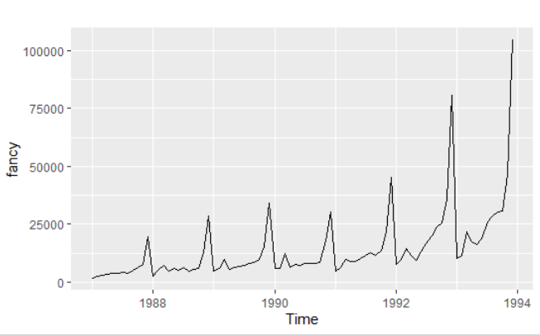

1. Explain why it is necessary to take logarithms of these data before fitting a model.
2. Use R to fit a regression model to the logarithms of these sales data with a linear trend, seasonal dummies and a “surfing festival” dummy variable.
3. Plot the residuals against time and against the fitted values. Do these plots reveal any problems with the model?
4. Do boxplots of the residuals for each month. Does this reveal any problems with the model?
5. What do the values of the coefficients tell you about each variable?
6. What does the Breusch-Godfrey test tell you about your model?
7. Regardless of your answers to the above questions, use your regression model to predict the monthly sales for 1994, 1995, and 1996. Produce prediction intervals for each of your forecasts.
8. Transform your predictions and intervals to obtain predictions and intervals for the raw data.
9. How could you improve these predictions by modifying the model?